MISSING TEETH

Q Why should I replace missing teeth?


A Your appearance is one reason. Another is that the gap left by a missing tooth can mean greater strain on the teeth at either side.

A gap can also mean your ‘bite’ is affected, because the teeth next to the space can lean into the gap and alter the way the upper and lower teeth bite together. This can then lead to food getting packed into the gap, which causes both decay and gum disease.

Q How are missing teeth replaced?

A This depends on the number of teeth missing and on where they are in the mouth. The condition of the other teeth also affects the decision.

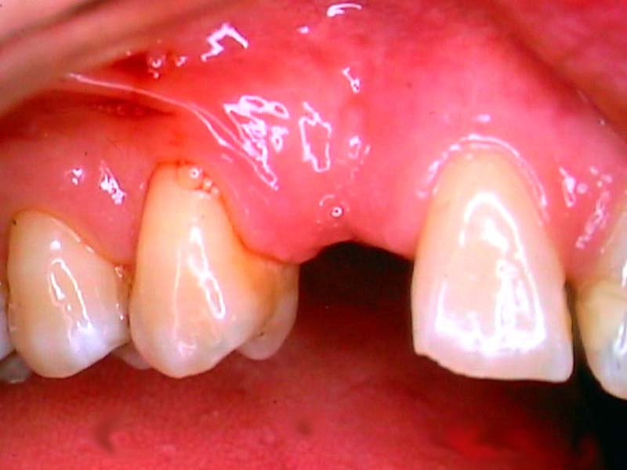

There are two main two ways to replace the missing teeth. The first is with a removable false tooth or teeth – a partial denture. The second is with a fixed bridge. A bridge is usually used where there are fewer teeth to replace, or when the missing teeth are only on one side of the mouth.

Q Can I always have a bridge to replace missing teeth?

A Yes, if you have enough strong
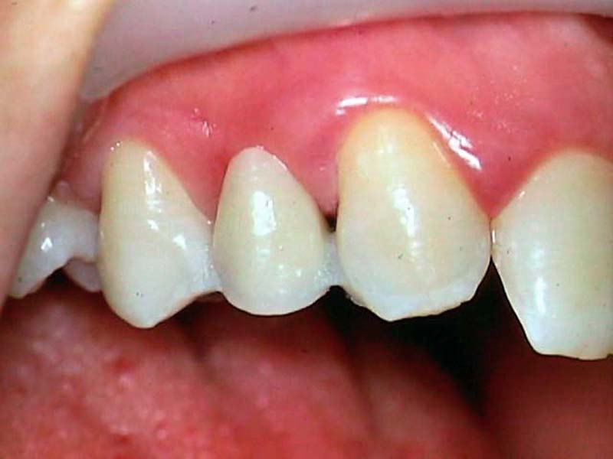
teeth with good bone support.
Your dentist will help you decide which is the best way of replacing the teeth within your budget.

Q Are there other methods for fixing false teeth?

A There are other methods, such as using a combination of crowns and partial dentures that can keep the retaining clips out of sight. These are quite specialised dentures, so you should ask your dentist about them. You can also have teeth implanted, ask your dentist for more information.

Remember that it’s as important to care for your remaining teeth as it is to replace the missing ones.

